
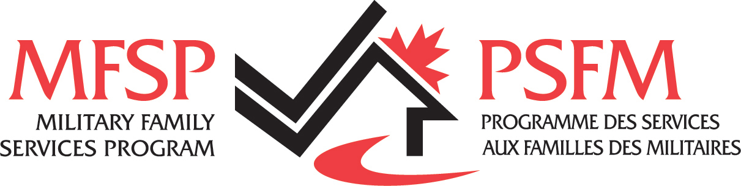

REGISTRATION FORM (Fall 2024)
FRENCH COURSE

Last name: First name:

Mailing Address: city: Postal code:

Email address:

Telephone: (home) (work)

Military Spouse/partner Military Member Civilian Other

Do you consider yourself a beginner? YES NO
Please describe your level of knowledge (i.e. previous French courses, French spouse, posting in Quebec, etc.)

In order to satisfy your needs, please indicate your preferred choice of schedules and learning mode. (Note: the final schedule and mode of learning will be based on demand)

2 mornings per week 2 evenings per week

2 afternoons per week

Please state any days you are not available _____________________________

Online (via Zoom meetings) in-person (Trenton MFRC site)

For new students, confirmation of your level will be made following a verbal assessment by telephone. Priority will be given to military spouses until the registration deadline. A minimum of 5 military spouses is required to run a course.
NOTE: Your attendance at all courses is very important. For the military spouses, the cost for this program is $50 and is refundable at the end of the session with the completion of the course (75% or more of the LRDG portal component completed and 75% or more attendance for the in-class portion of the course) and the exams.
The cost for military members is $85 and $150 for civilian. The fees for military members and civilians are non-refundable at the end of the session.
Students who cancel a SLT course within a week or less before the start of the course or who drop out of a course are not eligible for registration fees/deposit refund or credit for another session.

By signing this form, I agree to the above conditions.

Date : Signature :

